**Question 2: For this question you’ll need to use SQL.**

**How many orders were shipped by Speedy Express in total?**

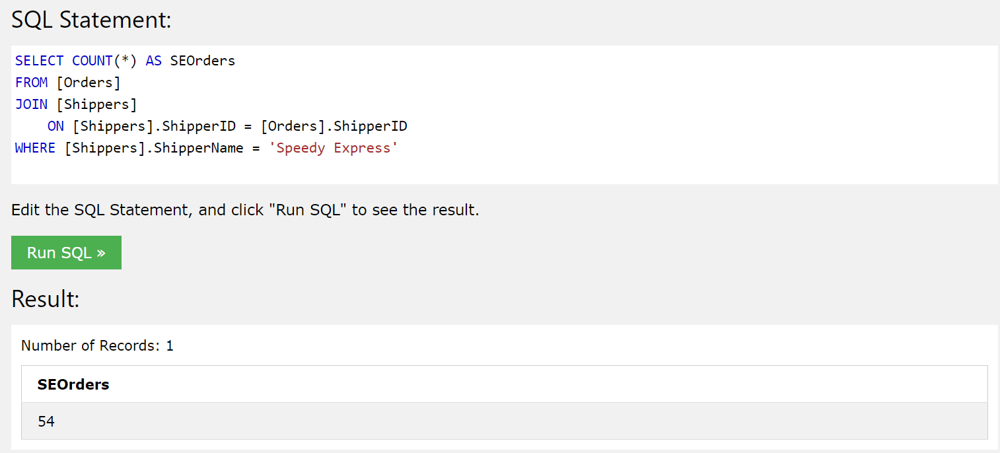

**What is the last name of the employee with the most orders?**

**Ans- Peacock**

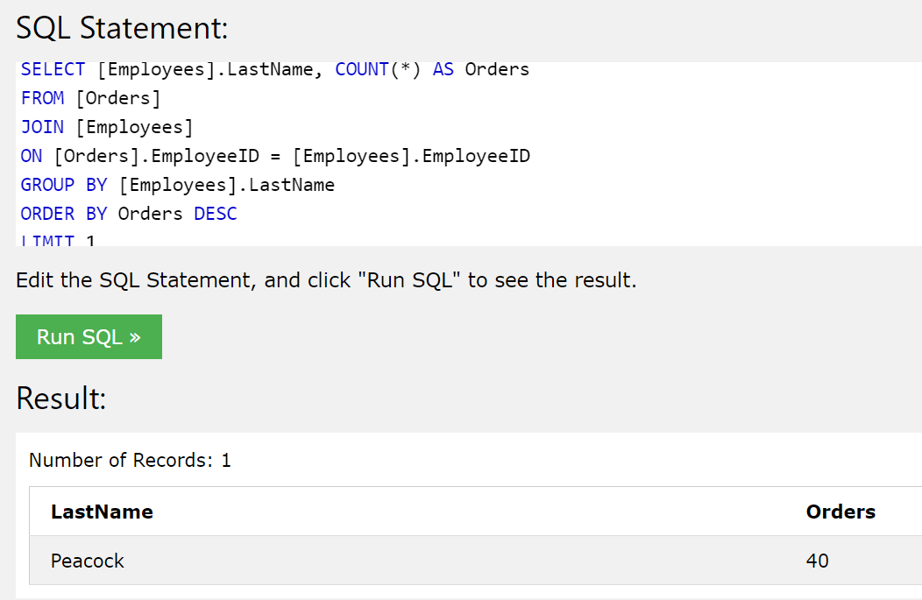

**What product was ordered the most by customers in Germany?**

SELECT [Products].ProductName,

SUM([OrderDetails].Quantity) AS "Total"

FROM [Orders]

JOIN [Customers]

ON [Customers].CustomerID = [Orders].CustomerID

JOIN [OrderDetails]

ON [OrderDetails].OrderID = [Orders].OrderID

JOIN [Products]

ON [Products].ProductID = [OrderDetails].ProductID

WHERE [Customers].Country = 'Germany'

GROUP BY [OrderDetails].ProductID

ORDER BY Total DESC

LIMIT 1

